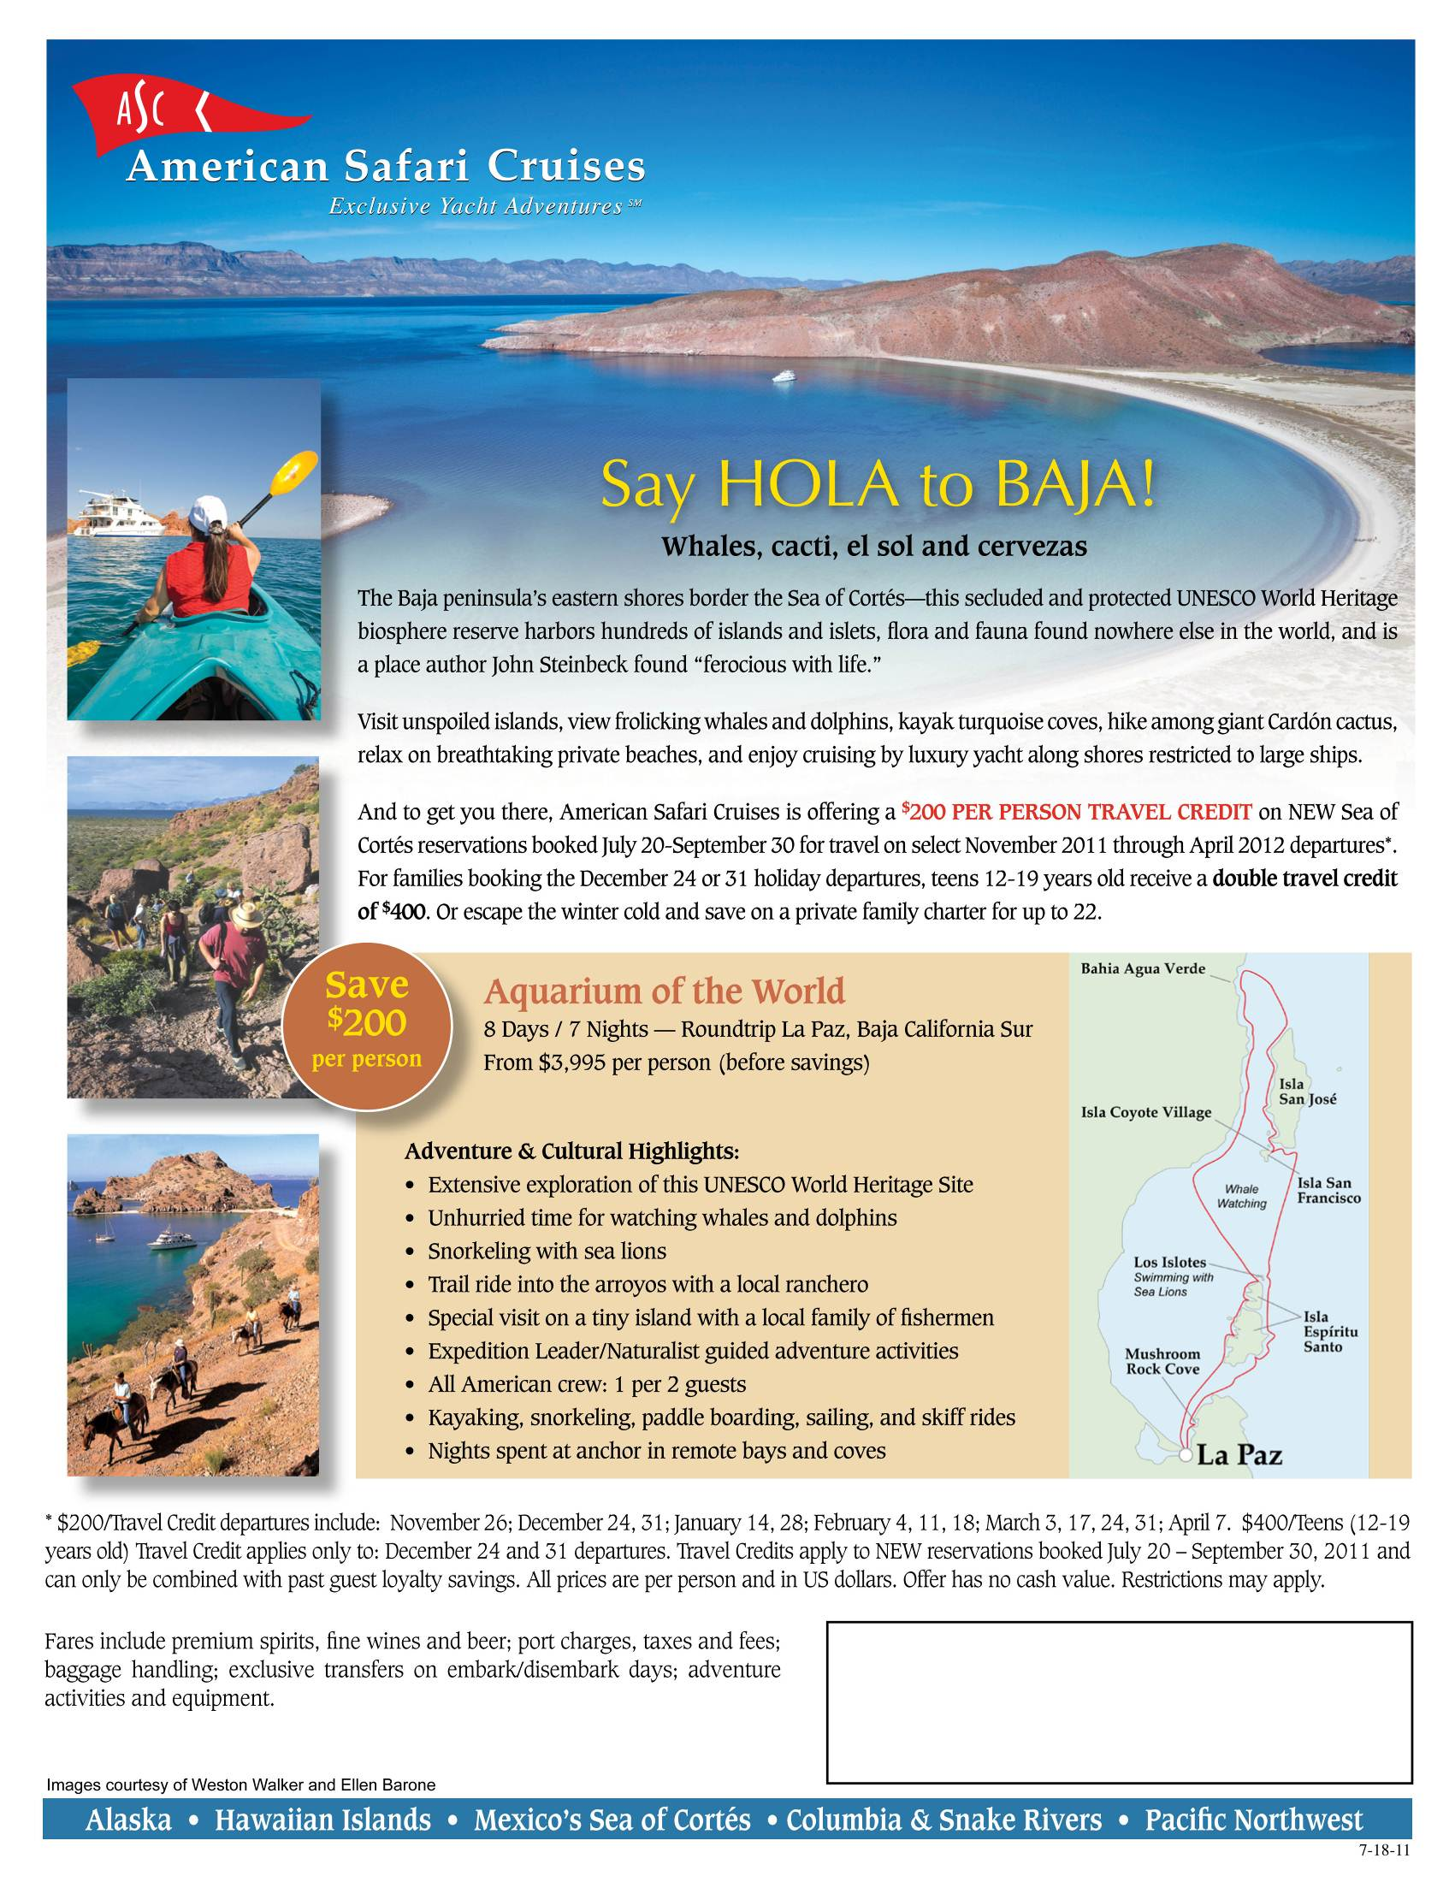
Brooks Cruise Services
Houston, TX
713-429-1487
Text 469-648-0571

