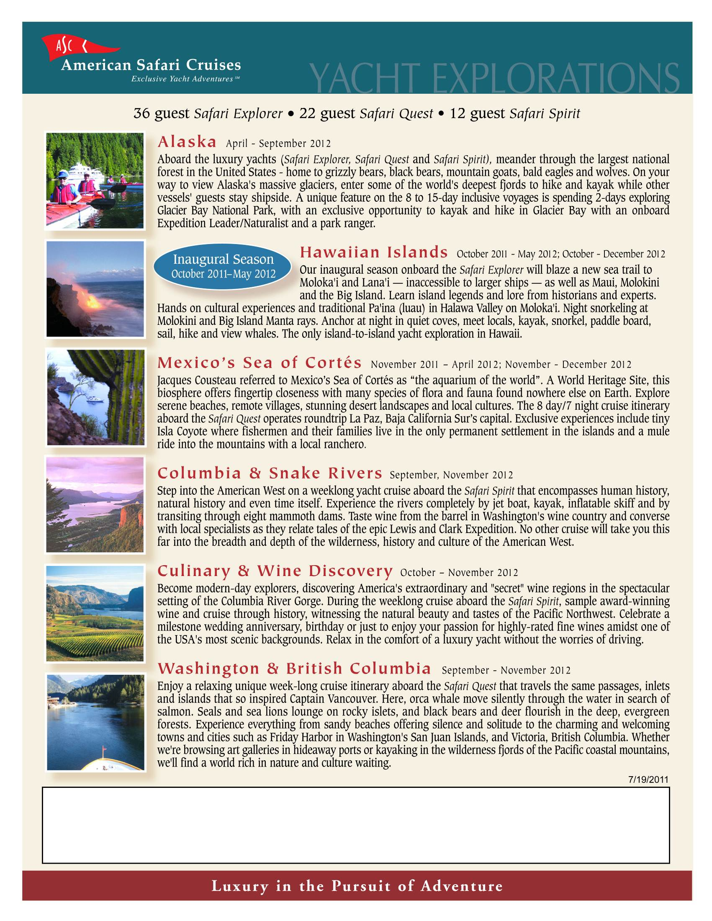
Brooks Cruise Services
David@BrooksCruiseServices.com
Phone 713-429-1487
Text 469-648-0571
