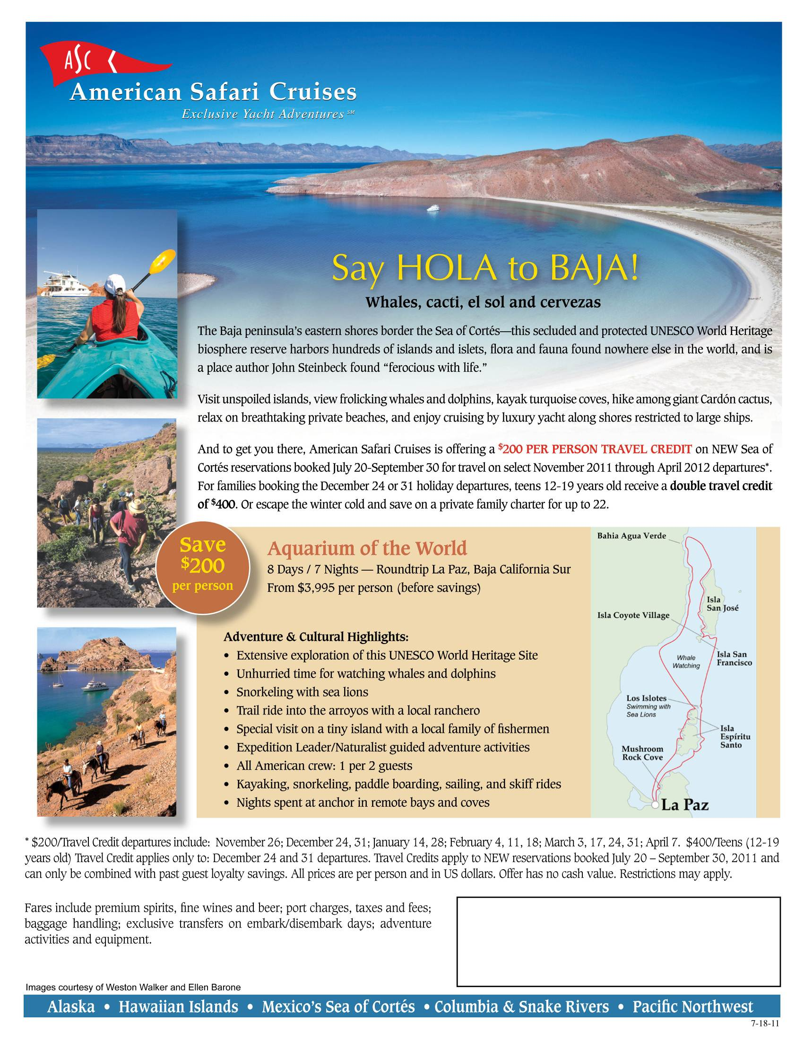
Brooks Cruise Services
American Safari Cruises Yachatalist
Houston, TX
713-429-1487

